**To check Read, Write and Execute on Network Drive**

**2.1. Network Drive**

## **:**

**2.1.1 Network Drive Setup**

* Login to the TS server.
* Open file explorer.
* Click on ‘This PC’.
* Click on computer (User can find the "Computer" tab on the top left).
* Click on 'map network drive'.
* Select Drive letter.
* Enter the NFS server IP address and shared folder into the 'Folder'.

**Example: -** \\<NFS_SERVER_IP_ADDRESS>\<shared_folder_name>

* Click on 'Finish' button.

**2.1.2 How to check Read, Write and Execute on Network Drive**

* Open the "File Explorer", in that go to "This PC ", there must be Network Drive (NFS Drive) is created.
* Right click on the created Network Drive (NFS Drive).
* There will be a popup box open.
* At the end of the popup box click on the Properties.
* In Properties on the upside, there is a "Security" box that will be present. Click on that.
* At the bottom of the "Security" box there will be a "Permission For Authenticated Users" table that will be present.

TS System Network Drive (NFS)

Logs

Fig 2.1: Execution Of command.

**How to create PowerShell script:**

1.Open PowerShell IDE and paste below content into PowerShell:

Function Write-Log

{

[CmdletBinding()]

Param(

[Parameter(Mandatory=$False)]

[ValidateSet("INFO","WARN","ERROR","FATAL","DEBUG")]

[String]

$Level = "INFO",

[Parameter(Mandatory=$True)]

[string]

$Message,

[Parameter(Mandatory=$False)]

[string]

$logfile

)

$content = "[$Stamp] [$Level] $Message"

if($logfile)

{

Add-Content $logfile -Value $content

}

else

{

Write-Output $content

}

}

function Get-CurrentLineNumber

{

$MyInvocation.ScriptLineNumber

}

$ScriptDirectory = "{{cache_dir}}"

$InstallerLogFileName="$ScriptDirectory\networkdrive_check_write.txt"

try

{

Copy-Item -Path '{{shared_dir}}\{{sample_file_name}}' -Destination {{networkdrive_letter}}:\

Write-Log "INFO" "[$(Get-CurrentLineNumber)] 'File Write successfully.' "$InstallerLogFileName""

}

catch

{

Write-Log "INFO" "[$(Get-CurrentLineNumber)] 'Exception Occur, Can not Write and Execute File.' "$InstallerLogFileName""

}

2.Save the file with ‘NetworkDrive_Check_RWX.ps1’

## **Evidence:**

* Local Execution with Evidence
* Login to the MD server.
* Open the "File Explorer", in that go to "This PC ", there must be Network Drive (NFS Drive) is created.

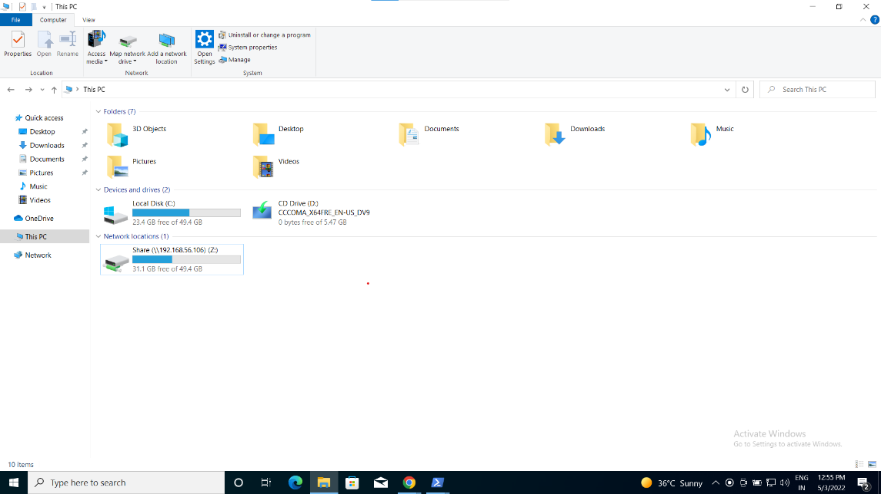

Fig 2.2: Into the File Explorer

* Right click on the created Network Drive (NFS Drive).
* There will be a popup box open.

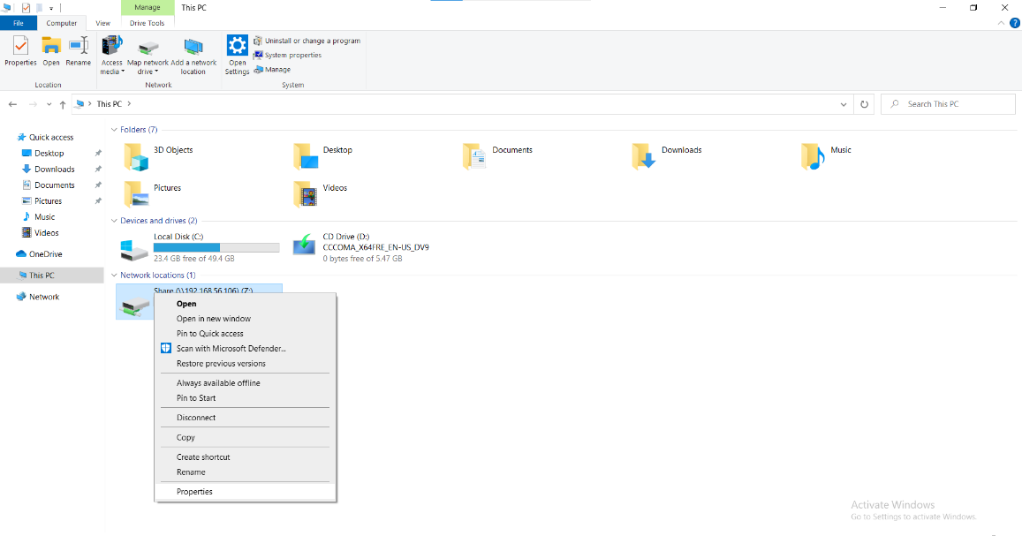

Fig.2.3: After right click popup window, at the end “Properties”

* At the end of the popup box click on the Properties.
* In Properties on the upside, there is a "Security" box that will be present. Click on that.

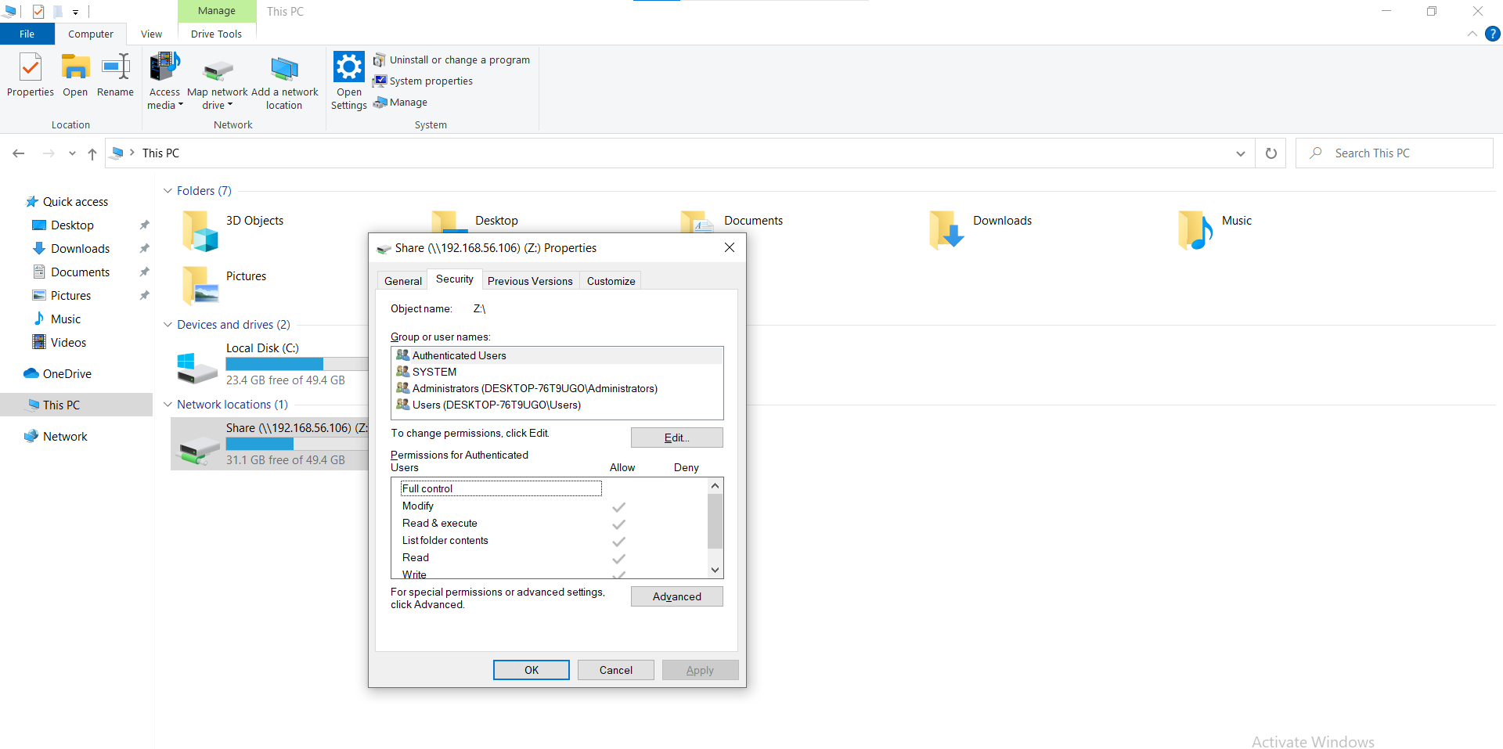

Fig2.4: Window For permission Access

* At the bottom of the "Security" box there will be a "Permission For Authenticated Users" table that will be present.
* To read, write and execute execute below commands on PowerShell.
* To write and execute execute below command:

Copy-Item -Path '<shared_dir>' -Destination \\<file_server_ip>\<file_server_shared_folder>

* To read from file\dir execute below command

Get-Childitem –Path \\<file_server_ip>\<file_server_shared_folder>

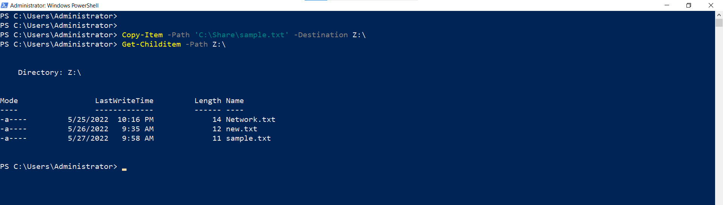

Fig 2.5: Read write and execute on shared file.

* Remote Execution with Evidence

**Command:**

python

import winrm

s = winrm.Session('192.168.56.117', auth=('Administrator','abc@123'))

r = r = s.run_ps('C:\\networkdrive_check_rwx.ps1')

r.status_code

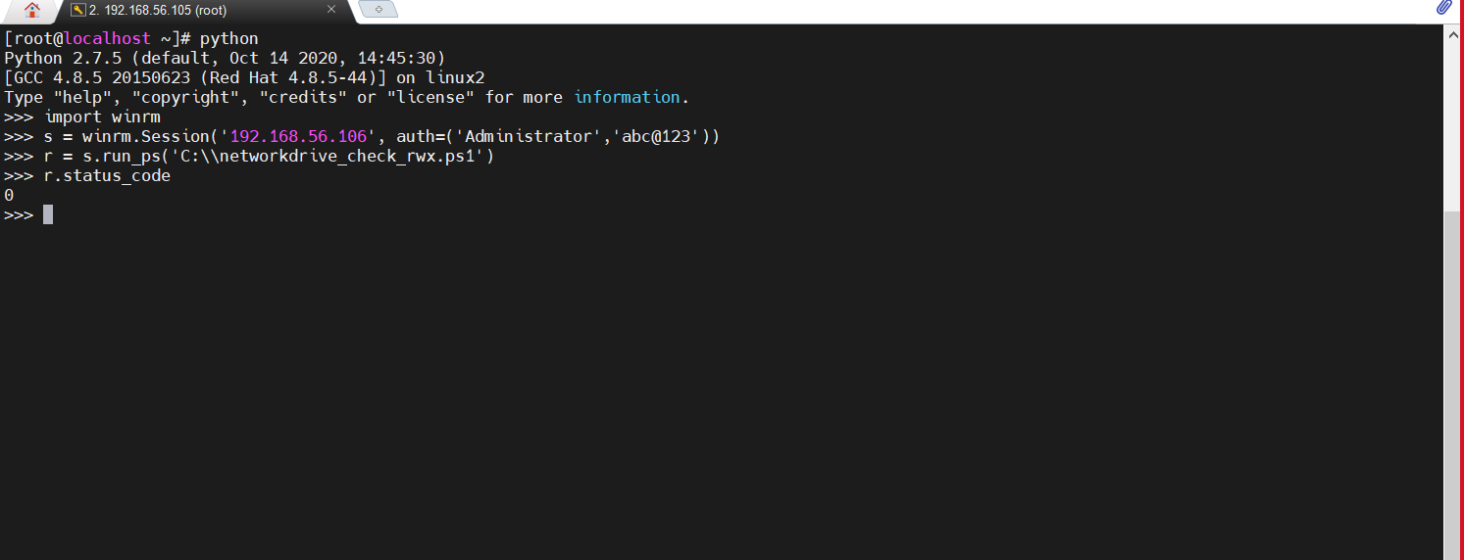

Fig. 2.6: Remote Execution on MD System Successful status evidence

## **Verification:**

* Login TS system.
* Open This PC.
* Go into local disk (C)
* Go into Share folder
* “networkdrive_check_write_execute.log & read.log” log file must be there

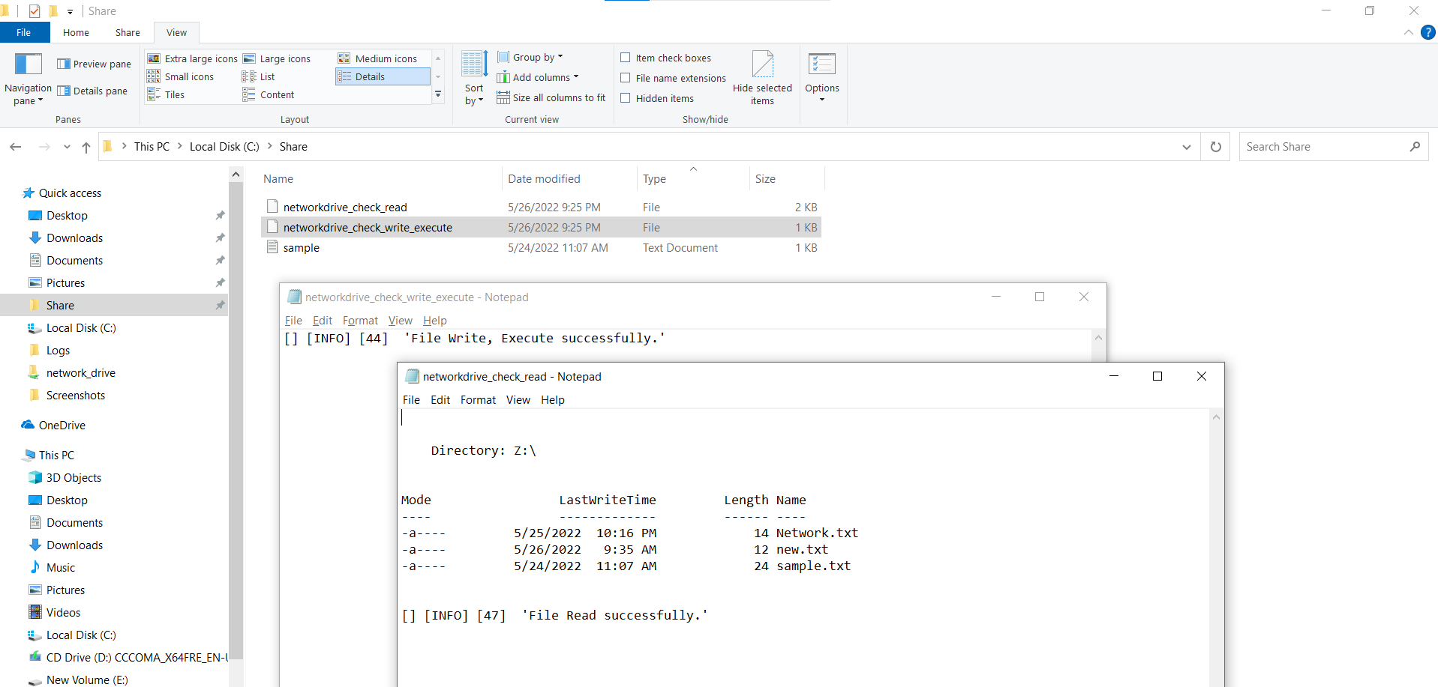

Fig. 2.7: “networkdrive_check_write_execute.log & read.log” log created on TS system after remote execution on MD System Successful